BEST MANAGEMENT PRACTICES
FOR PLANTS OF CONCERN

Practices Developed to Reduce the Impacts of
Oil and Gas Development Activities
to Plants of Concern

Prepared by the Colorado Rare Plant Initiative

Brian A. Elliott, Botanical Consultant,
Susan Spackman Panjabi, Colorado Natural Heritage Program,
Betsy Neely, The Nature Conservancy,
Renée Rondeau, Colorado Natural Heritage Program,
Brian Kurzel, Colorado Natural Areas Program,
and Mo Ewing, Colorado Open Lands
DRAFT 3/10/2008

TABLE OF CONTENTS
Introduction 1
Project Planning Phase 2
Pre-Ground Disturbance Fieldwork Phase 3
Project Implementation Phase 4
Revegetation and Invasive Plants 5
Post-Project Monitoring 6
References 6

Introduction
Sixteen globally imperiled plants found in oil and gas development areas in Colorado are in danger of extinction (Table 1). Collectively, these species occupy less than 30,000 acres in Colorado (Figure 1 and Table 1). Avoiding or minimizing impacts to these species during oil and gas development activities will reduce the likelihood of future listings under the Endangered Species Act, and is unlikely to confer substantial impacts on oil and gas development projects.

The desired outcome of the BMPs listed below is to significantly reduce the impacts of oil and gas development to the sixteen plants of concern on federal, state, and/or private land. These BMPs are not intended to replace other BMPs written for specific species or habitats. The BMPs listed here are intended to be iterative, and to evolve as additional information becomes available about Colorado’s botanical diversity, and as resource extraction and resource conservation technologies develop.

Project Planning Phase

- Gather mapped location information for plants of concern (Table 1) in potential project areas by consulting with the Colorado Natural Heritage Program at Colorado State University and the U.S. Fish and Wildlife Service.

- If plants of concern (Table 1) are known from the vicinity of potential project areas or suitable habitat is present (Figure 2), plan to conduct field surveys for the plants of concern (see also Pre-Ground Disturbance Fieldwork section of this document).

- Prior to field surveys, the proponent or operator should provide maps (as hard-copy and GIS files) to a botanical surveyor showing all known locations for the plants of concern, as well as the proposed areas of disturbance. Maps should include existing and proposed roads, pipelines, well pads, ponds, pits, parking lots, all other work areas, and any area liable to be subjected to ground disturbance. These maps should be updated as new sites are proposed.

- If federally listed Threatened, Endangered, Candidate, or Proposed plant species are found on federal lands, consultation with the Fish and Wildlife Service is necessary.

- If populations of plants listed in Table 1 are found, assure that they are placed on updated project maps.

- No surface occupancy or ground disturbance is recommended in Areas of Critical Environmental Concern (ACECs) designated for rare plant values, or in known occupied habitat for plants listed in Table 1.

- Where plants of concern (Table 1) are found, an avoidance buffer of 200 meters minimum is recommended. The 200 meter buffer reduces dust transport, weed invasion, unauthorized vehicular activities, and chemical and produced-water spills. It also reduces impact to pollinators and their habitat. Pesticide application and use of prescribed fire should be avoided throughout known occupied habitats.

- Where avoidance is not feasible and development is allowed within 200 meters of plant populations, impacts to the plants of concern can be reduced by placing temporary fencing around the perimeter of the project area so that the sensitive habitat is avoided as much as possible.

- Ex-situ techniques such as transplantation are not recommended under any circumstances.

- Minimize impacts to habitat for plants of concern through appropriate and creative project planning. Some examples of appropriate and creative project planning include:
- Place well pads, roads, pipelines, structures, and associated infrastructure where they will cause the least impact to the plants of concern.
- Maximize distance between well pads by use of directional drilling.
- Sell gas leases in blocks that facilitate maximum surface spacing.
- Construct the smallest well pads and access needed to safely develop the site.
- Minimize the length of new roads, and use existing roads wherever possible.
- Prevent unauthorized use of temporary roads.
- Use primitive or two-track roads rather than newly constructed roads where feasible.
- Build roads to the appropriate standard, no higher than necessary for use and safety; reduce right-of-way width and minimize the depth of roadbed excavation to minimum requirements.
- Limit new access routes created by the project.
- Place signing to limit off-road travel in sensitive areas.
- Pipelines (and electrical powerlines when possible) should be placed within road corridors to minimize disturbance
- Fire retardant chemicals should not be applied to plants of concern.
- Pesticide applications should be kept at least 200 meters from known plants of concern locations. When weed populations threaten habitat integrity or plant populations a lesser distance may be considered after consultation with Fish and Wildlife Service (for listed plants) or the agency botanist (for non-listed plants of concern). Great care should be used to avoid pesticide drift in those cases.
- Alteration and disturbance of the hydrological setting for plants of concern should not be permitted.
- Off-site impacts or indirect impacts should be avoided (i.e., install berms or catchment ditches to prevent spilled materials from reaching occupied or suitable habitat through either surface or groundwater.
- Overspray from evaporation ponds should be located such that it falls at least 200 meters from habitat for plants of concern.
- Construction should take place down slope of plants of concern where feasible. If well pads and roads must be sited upslope, buffers of 200 meters minimum between surface disturbances and plants of concern should be incorporated.

Pre-Ground Disturbance Fieldwork Phase
- Field botanical surveys are recommended for all projects that overlap the range of the plants of concern (Figure 2) to determine if plants of concern (Table 1) or suitable habitat are present. If possible, all plants tracked by the Colorado Natural Heritage Program should also be documented in the surveys (Colorado Natural Heritage Program 2008).

- Field botanical surveys should be conducted by qualified individual(s) with botanical expertise and according to commonly accepted survey protocols. The Colorado Natural Heritage Program at Colorado State University can provide references, field forms, etc.

- Field botanical surveys should be conducted at a time when the plant species of concern can be detected and accurately identified.

- Field botanical surveys should be completed across the project disturbance area and include a 200 meter buffer around the project area. In some cases the topographic setting or land ownership patterns may impede covering the full recommended survey area. Surveys should also include areas where direct or indirect effects may impact hydrology.

- If plant species of concern are found within the survey area, the botanist should endeavor to determine the complete extent of the occurrence and the approximate number of individuals within the occurrence.

- Field survey results should be reported to the Colorado Natural Heritage Program at Colorado State University, and to appropriate land managers.

- Prepare a reclamation plan prior to ground-disturbing activities. Realize that seeding or planting may need to be repeated until deemed successful (see also the Revegetation and Invasive Plants section of this document).

Project Implementation Phase
- Verify that field surveys and all other planning phase activities have been completed.

- Control erosion and polluted runoff in areas that would impact plants of concern.

- Perform frequent and timely inspections of development sites and plants of concern occurrences to ensure that BMPs are being followed, and to identify areas of potential conflict.

- Restrict motorized travel to designated roads and trails. Routes should be designated and marked prior to implementation.

- Prevent plumes of dust and particulate matter from impacting plants of concern. While new roads should not be built within 200 meters of the plants of concern, preexisting roads with an expected increase in traffic should be graveled in these areas. The operator is encouraged to apply water for dust abatement to such areas during the flowering period. If possible, dust abatement applications should be comprised of water only, with minimal use of magnesium chloride.

- Minimize disturbance to soil and native vegetation as much as possible.

Revegetation and Invasive Plants
- Rigorously monitor and control all infestations of noxious weeds (Colorado Noxious Weed Act 2003) and other non-native invasive plant species in occupied habitat for plants of concern.

- Monitor project areas for new weed infestations. Noxious weeds in close proximity (within ¼-1/2 mile) to the plants of concern should be the highest priority for control.

- When timely natural regeneration of the native plant community is not likely to occur, carefully select and use native species that will not compete with or exclude botanical resources for revegetation efforts. Nonnative invasive plant species should not be used under any circumstances.

- Ensure that seed used for revegetation is certified free of noxious weeds.

- Wash vehicles and other equipment to reduce the spread of noxious weeds from other areas.

- Minimize the disturbed area of producing well locations through interim and final reclamation. Reclaim well pads following drilling to the smallest area possible.

- Stockpile topsoil for use in final reclamation. Topsoil should be stored separately from other fill materials.

- Close and rehabilitate roads quickly once they are no longer needed.

- Monitor revegetation sites to ensure successful establishment of desired species.

- Use only certified weed-free mulch and hay in revegetation efforts.

- Re-contour roads to blend into the landscape; ripping and seeding roads are usually not sufficient.

- Protect cut-and-fill slopes against erosion with the use of water bars, lateral furrows, or other appropriate measures. Biodegradable straw matting, bales or wattles of weed-free straw or weed-free native grass hay, or well-anchored fabric silt fence should be used on cut-and-fill slopes and along drainages to protect against soil erosion.

- Develop monitoring plans for noxious weeds, especially in revegetation areas. Plans should be designed to detect new infestations and document the extent and spread of existing weeds.

Post-Project Monitoring
- Monitor impacts from oil and gas development on plants of concern. If impacts are noted, change management to address the cause of impacts.

- Monitor the long-term success of revegetation efforts to ensure successful establishment of desired species and detect any noxious weed infestations. If revegetation is unsuccessful, continue efforts to establish native species in disturbed sites.

References

ALL Consulting. 2002. Handbook on Best Management Practices and Mitigation Strategies for Coal Bed Methane in the Montana Portion of the Powder River Basin.

BLM. 2004. Best Management Practice Information Sheets. (WO1_WO_BMPs_Technical_Information_Sheets)

BLM 2006. BLM Programmatic Consultation for Resource Management Plan Implementation: Proposed Project Design Criteria.

BLM White River Field Office. Undated excerpt. Piceance Development Project.

California Native Plant Society. 1992. Policy on Appropriate Application of Ex Situ Conservation Techniques.

Colorado Bird Observatory. Undated. Best Management Practices for Shortgrass Prairie Birds: A Landowner’s Guide.

Colorado Mule Deer Association and the Colorado Wildlife Federation. 2006. Wildlife Management Guidelines for Oil & Gas Development.

Colorado Natural Heritage Program. 2008. Biodiversity Tracking and Conservation System. Colorado State University, Fort Collins, Colorado.

Colorado Noxious Weed Act. 2003. Title 35: Agriculture, Article 5.5: Colorado Noxious Weed Act, and 8 CRR 1203-19 Rules pertaining to the administration and enforcement of the Colorado Noxious Weed Act.

Federal Register: 2006. Notice of Proposed Plant Materials Policy, Forest Service Manual. Vol. 71, No. 102: 30375-30376.

Horizon Environmental Services 2004. Guidance Document Reasonable and Prudent Practices for Stabilization (RAPPS) of Oil and Gas Construction Sites HJN 040027 IM.

U. S. Department of the Interior and United States Department of Agriculture. 2007. The BLM GOLD BOOK: Surface Operating Standards and Guidelines for Oil and Gas Exploration and Development. BLM/WO/ST-06/021+3071/REV 07. Bureau of Land Management. Denver, Colorado. 84 pp.

U.S. Fish and Wildlife Service. 1999. Biological Opinion for the Proposed Inland Production Company Road, Water Pipeline and Natural Gas Pipeline and Potential Well Development within Inland’s Humpback and Greater Boundary Oilfield Units.

U.S. Fish and Wildlife Service. 2006. Proposed Best Management Practices (Conservation Recommendations): Colorado State-wide Programmatic Consultation.

U.S. Fish and Wildlife Service. 2007. FWS/BLM Recommendations for Avoiding Adverse Effects on Threatened, Endangered, Proposed, and Candidate plants; updated draft 9-21-2007.

U.S. Fish and Wildlife Service. 2007 Ute ladies’-tresses (Spiranthes diluvialis) Conservation Measures.

U.S. Fish and Wildlife Service. 2008. Grahams Beardtongue Conservation Measures.

U.S. Fish and Wildlife Service. 2008. Uinta Basin hookless cactus Conservation Measures.

U.S. Fish and Wildlife Service. 2008. White River beardtongue (Penstemon scariosus var. albifluvis) Conservation Measures.

U.S. Forest Service. FSM 2070: Native Plant Materials.
Table 1. Sixteen plants of concern that are the primary focus of these BMPs. All of these taxa are threatened with extinction because of oil and gas development activities in Colorado (Decker et al. 2007, Colorado Natural Heritage Program 2008).

Scientific name | Imperilment rank (CNHP 2008) | Federal Status | Endemic to Colorado | Occupied acres in Colorado | Habitat
Astragalus humillimus | G1/S1 | LE | No | 1433 | Cliff and canyon
Astragalus debequaeus | G2/S2 | BLM | Yes | 106 | Pinyon-juniper
Astragalus osterhoutii | G1/S1 | LE | Yes | 793 | Shrubland
Cryptantha gypsophila | G1G2/S1S2 |  | Yes | 525 | Pinyon-juniper
Eriogonum pelinophilum | G2/S2 | LE | Yes | 1178 | Shrubland
Lesquerella congesta | G1/S1 | LT | Yes | 740 | Barrens
Lesquerella parviflora | G2/S2 | BLM | Yes | 3272 | Barrens
Mentzelia rhizomata | G2/S2 |  | Yes | 4547 | Barrens
Penstemon debilis | G1/S1 | C | Yes | 60 | Barrens
Penstemon fremontii var. glabrescens | G3G3T2/S2 |  | Yes | 3416 | Shrubland
Penstemon grahamii | G2/S1 |  | No | 639 | Barrens
Penstemon scariosus var. albifluvis | G4T1/S1 | C | Yes | 124 | Barrens
Phacelia scopulina var. submutica | G2T2/S2 | C, FS | Yes | 586 | Barrens
Physaria obcordata | G1G2/S1S2 | LT | Yes | 473 | Barrens
Sclerocactus glaucus | G3/S3 | LT | Yes | 10203 | Barrens
Thalictrum heliophilum | G2/S2 |  | Yes | 457 | Barrens
Total Acres |  |  |  | 28,559

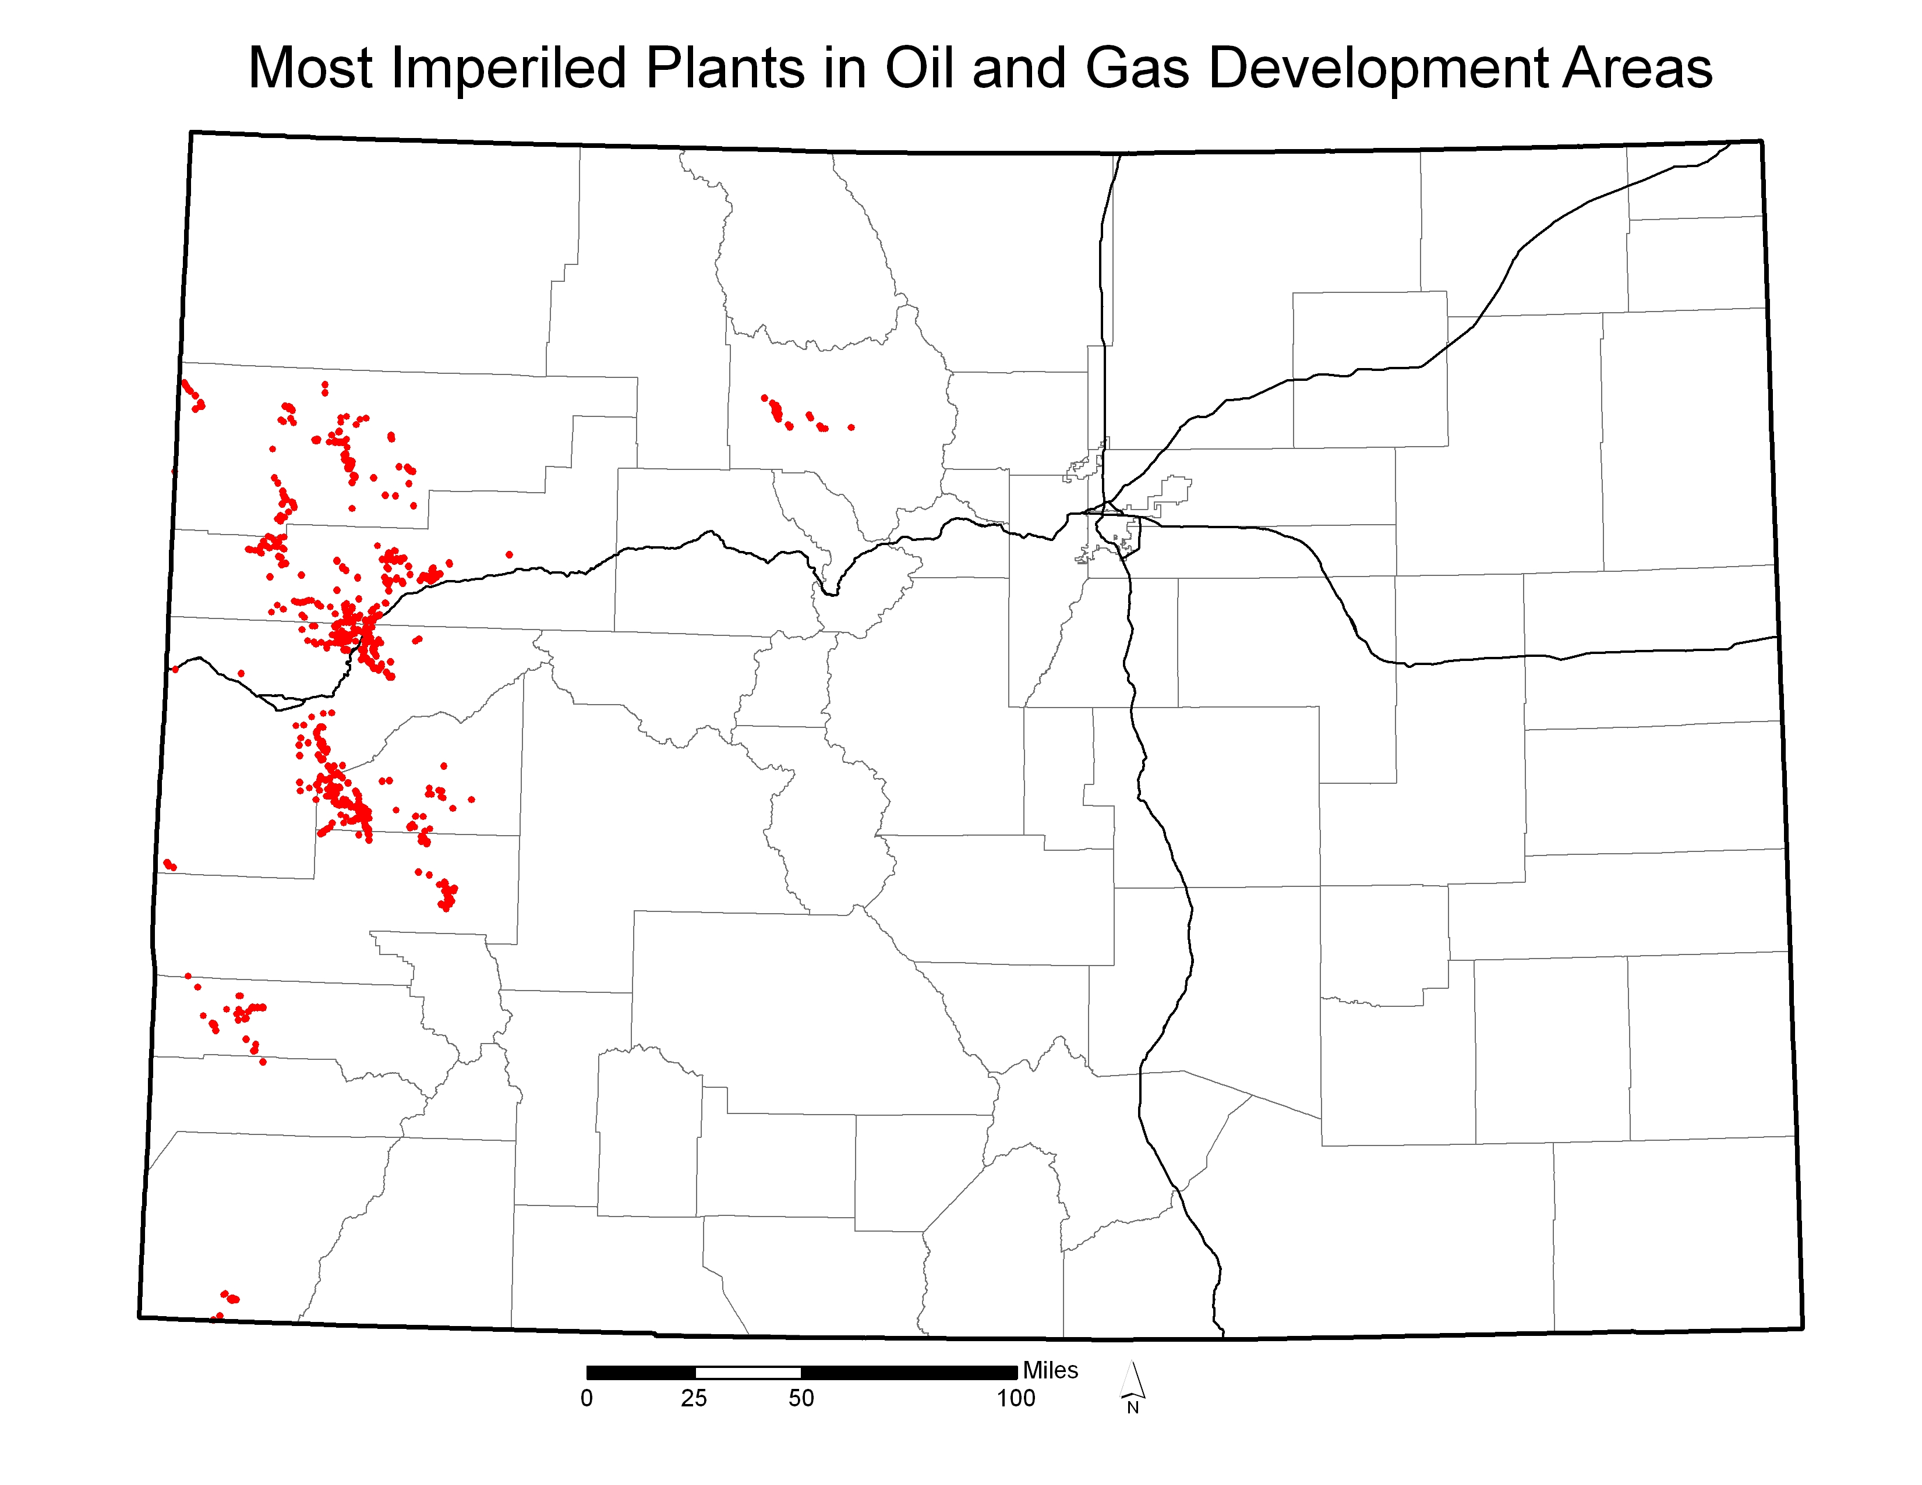
Figure 1. Occupied habitat for the sixteen plants of concern. Total occupied acreage is less than 30,000 acres (Colorado Natural Heritage Program 2008).
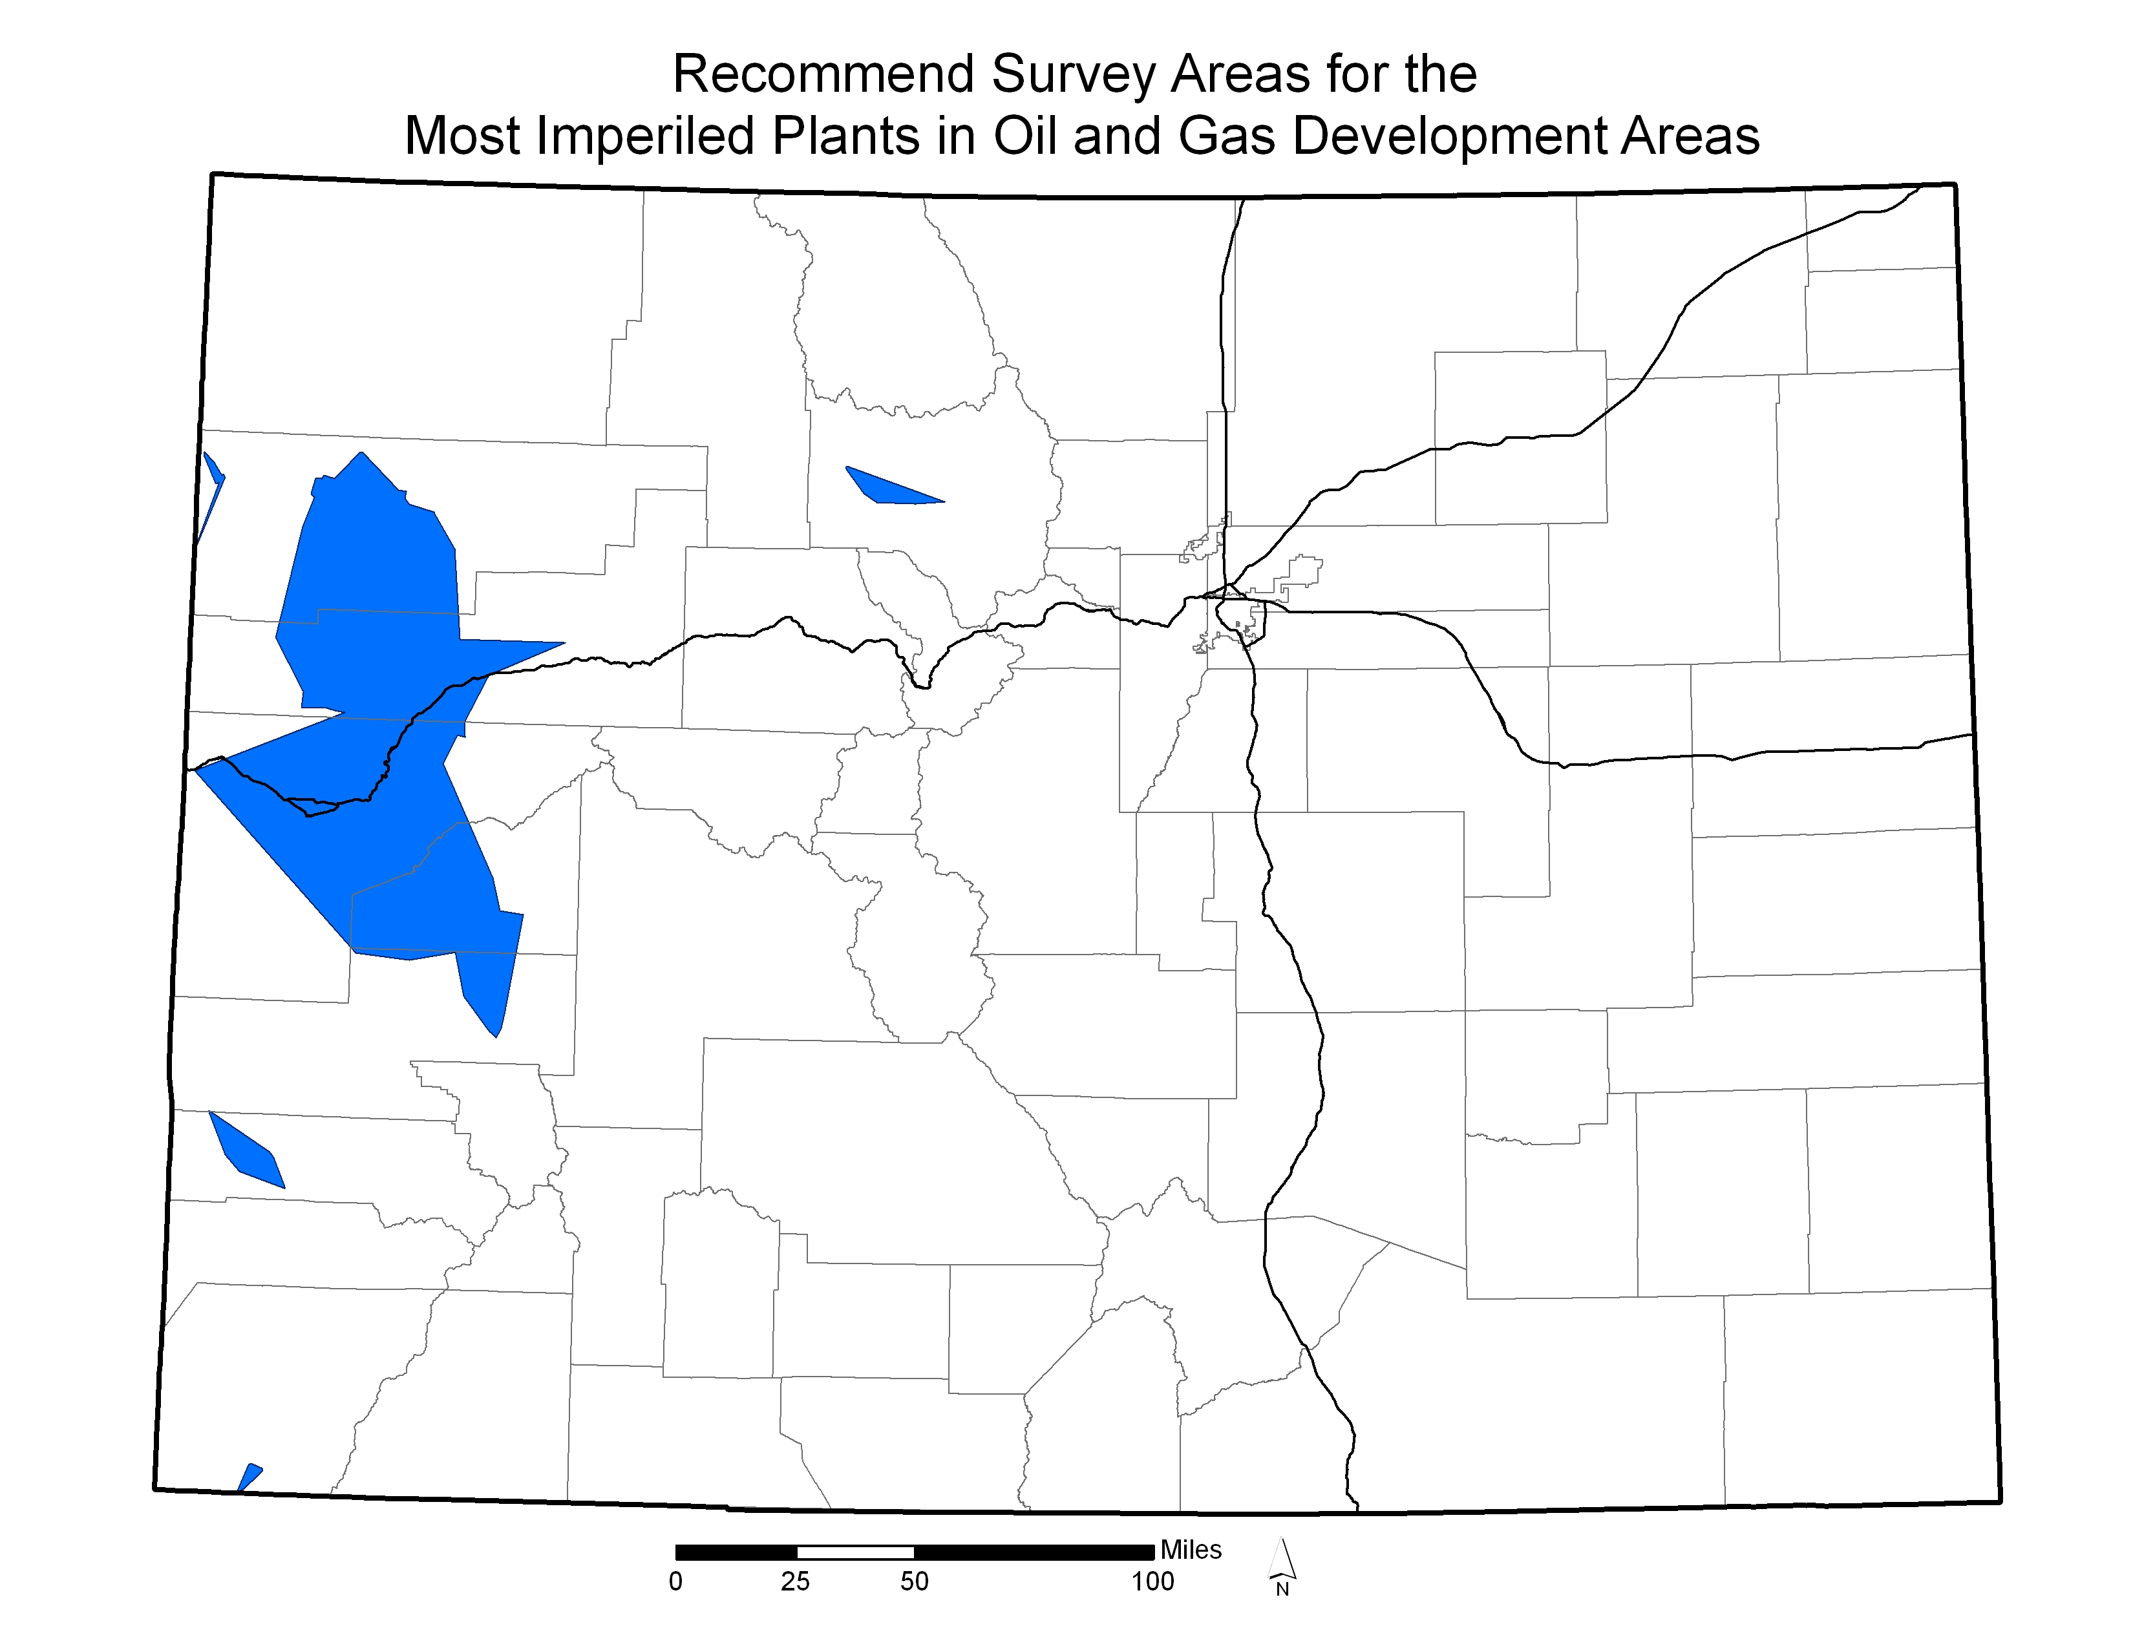

Figure 2. Areas recommended for survey for the sixteen plants of concern. These areas include the full range of the sixteen plants of concern in Colorado (Colorado Natural Heritage Program 2008).

